
Unit 16
377-399 London Road
Surrey GU153HL
United Kingdom

Press Release

Compostable Plastic Free Hot Cups & Containers

We are pleased to announce the release of a range of fully COMPOSTABLE, fully RECYCLABLE and fully REPULPABLE hot drink cups and takeaway containers.
You can have your logos, your corporate colours added in an environmentally friendly water based ink.
Single, double and triple wall cups that will promote you as a company that wants to make an environmental difference.

Yours Sincerely
GO PRO NOW LIMITED
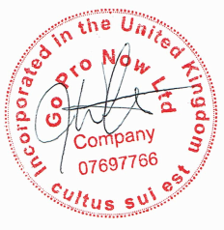

JAMES WESTON
MANAGING DIRECTOR

Tel: +44 (0) 207 9711184 Company number:07697766 VAT: 117 7730 10 EORI GB117773010000 DUNS 217354110

